

Ship Schedule
Design Document

Revision History
Date | Version | Description | Author
08/28/07 | 1.0 | Created | Jim Heary

Table of Contents
Overview 3
Business Context 3
Key Abstractions 4
Object States 5
Application Design 6
Overview 6
Design Model 6
Security 6
Deployment 7
Overview 7
Deployment Model 7
Runtime Configuration 7

Overview
The User needs the ability to create, view, and modify a Ship Schedule.

Business Context

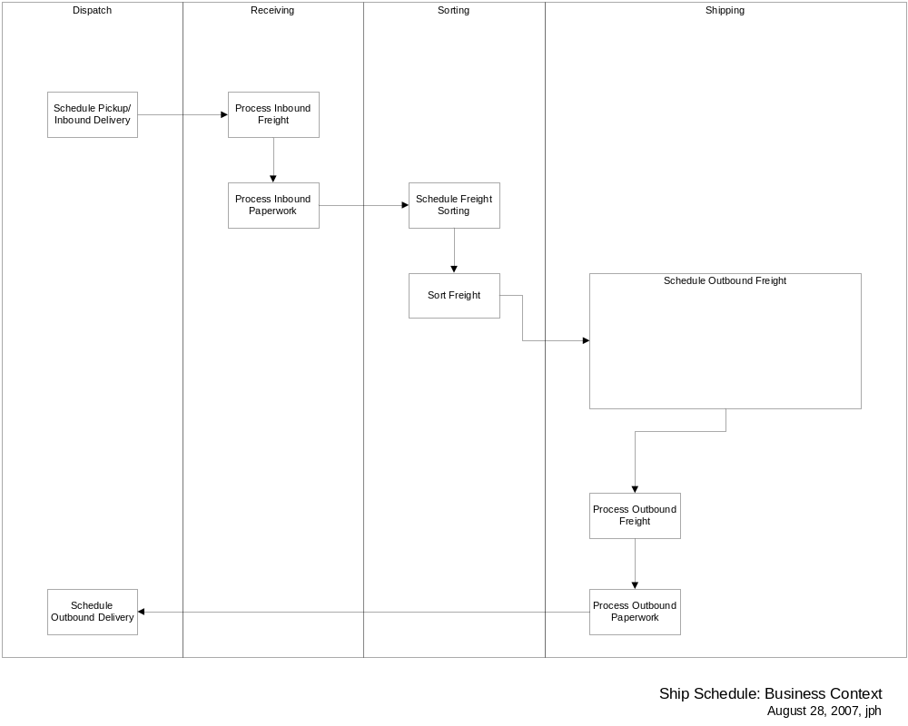

Key Abstractions

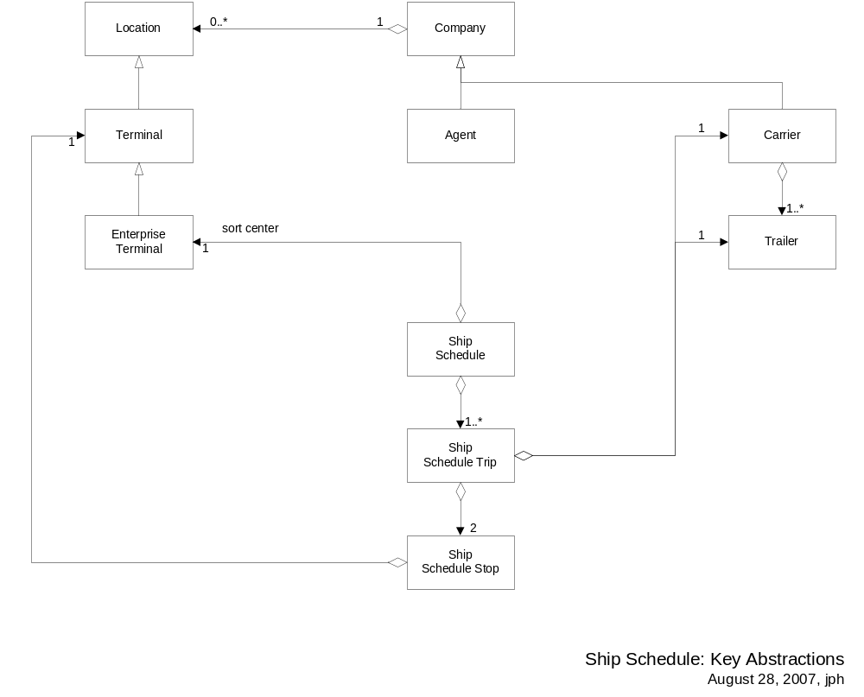

Object States

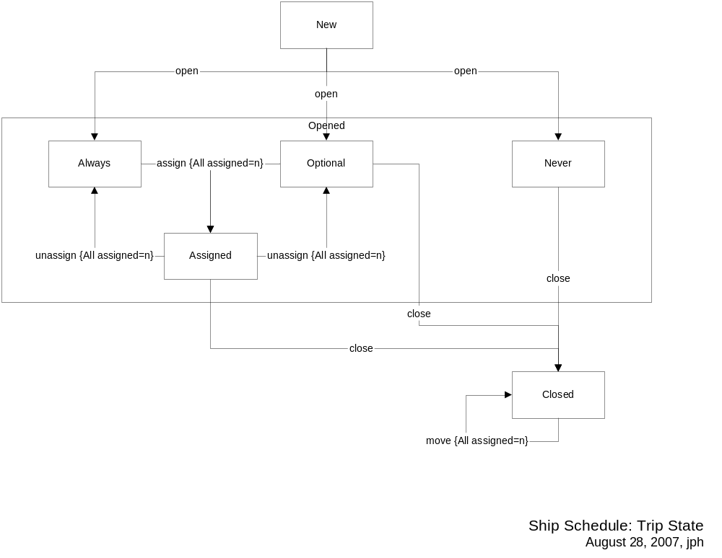

Application Design

Overview

Design Model

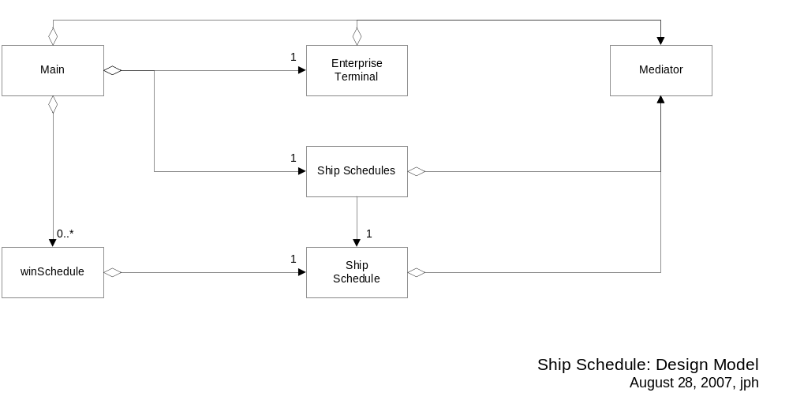

Security
The application has three levels of access:
LineHaulOperator
- view any ship schedule
- update Tractor#, Freight Assigned, Trailer Complete, Paper Complete, and Trailer Dispatch
- print and export any ship schedule
LineHaulCoordinator
- all features of LineHaulOperator
- update Close Time/Day, Trailer, Carrier, Depart Time/Day, Notes, Arrival Date/Time, OFD Date
LineHaulAdministrator
- all features of LineHaulCoordinator
- create new ship schedules
- add new loads (from templates) and cancel existing loads on ship schedules
- send ship schedules reports to agents and carriers

Deployment

Overview

Deployment Model

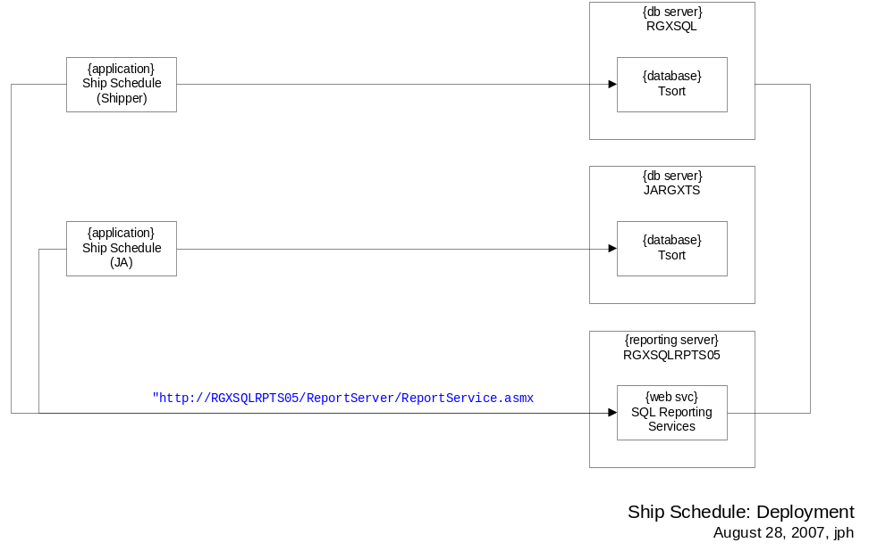

Runtime Configuration
Open the local sort database (i.e. TSORTLOCAL on RGXDEVDB), go to the Configuration table, and add/edit the
values below:
Application PCName Key Value Security
--------------- --------------- ------------------------- ------------------------- --------
Ship Schedule Default MISPassword ******** 1
Ship Schedule Default Role LineHaulOperator 1
Ship Schedule Default TraceLevel 3 1
Ship Schedule jheary Role LineHaulAdministrator 1
Ship Schedule jheary2 Role LineHaulCoordinator 1

Open the application configuration file (i.e. ShipSchedule.exe.config), go to the <configuration> section,
and add/edit the values below:
<configuration>
<!-- Jamesburg configuration -->
<configSections>
<sectionGroup name="menu">
<section name="help" type="System.Configuration.NameValueSectionHandler" />
</sectionGroup>
</configSections>
<menu>
<help>
<add key="Help Contents" value="" />
<add key="Release Notes..." value="" />
<add key="Issue Log..." value="" />
</help>
</menu>
<appSettings>
<!-- Client configuration -->
<add key="ADPath" value="LDAP://argix/DC=argix,DC=com" />
<add key="CarrierReportPath" value="/Shipping/Carrier Ship Schedule" />
<add key="AgentReportPath" value="/Shipping/Agent Ship Schedule" />
<add key="ExportDefinitionFile" value="http://RGXWEB/ShipSchedule-JA/" />
<add key="PastBusinessDays" value="2" />
<add key="CanEditFreightAssigned" value="false" />
<add key="IsShipperSchedule" value="false" />

<add key="EventLogMachineName" value="RGXWEB" />

<!-- Tsort.Data configuration -->
<add key="Schedule.SQLReportServer.ReportingService" value="http://RGXSQLRPTS05/ReportServer/ReportService.asmx" />
<add key="SQLConnection" value="data source=JARGXTS;initial catalog=TSORT;persist security info=True;user id=*;password=*;packet size=4096" />
<add key="CommandTimeout" value="30" />
</appSettings>
</configuration>

